COVID-19: What to do before, during
and after a repair is carried out
Dear tenants,
We are writing to let you know how to report repairs required at your property in the wake of the COVID-19 global pandemic.
Despite the many changes to our day-to-day lives, it is vital to keep up to date with your repairs and maintenance. We endeavor to follow government guidance during the ongoing pandemic and as things stand tenants are encouraged to report repairs as normal.
Before
It is particularly important to include as many details about your repair issue in your report as possible, and where applicable include photographs and videos. These will allow much of the diagnostics to take place before the contractor visits and will minimise the contact time. For example, if we obtain the make and model of your boiler from the first instance, our contractor can bring relevant parts and tools with them when they attend to the issue for the first time.
Please also be sure to disclose everything that might be relevant in order for your property manager to make the most well-informed decision about whether or not a contractor call-out is required. Priority will be given to urgent health and safety issues and we will respond to all repair requests appropriately. You should also inform us of relevant health circumstances of those in your household. Where required, please consider getting a low-risk helper to come and help manage contact with the contractor if you do not feel able to manage this yourself. Please let us know about this so we can assess the risks involved before arranging a call-out.
During
In the event that a contractor does have to visit your home, please make every effort to reduce your contact with them. Where possible, open windows to improve ventilation in the room where the repair is being carried out. Once you have identified the problem, please maintain at least a two-metre distance from them, staying in separate rooms if possible. Please refrain from offering hot drinks or handshakes during these times. Be aware that they will be trying to keep their visit as brief as possible.
After
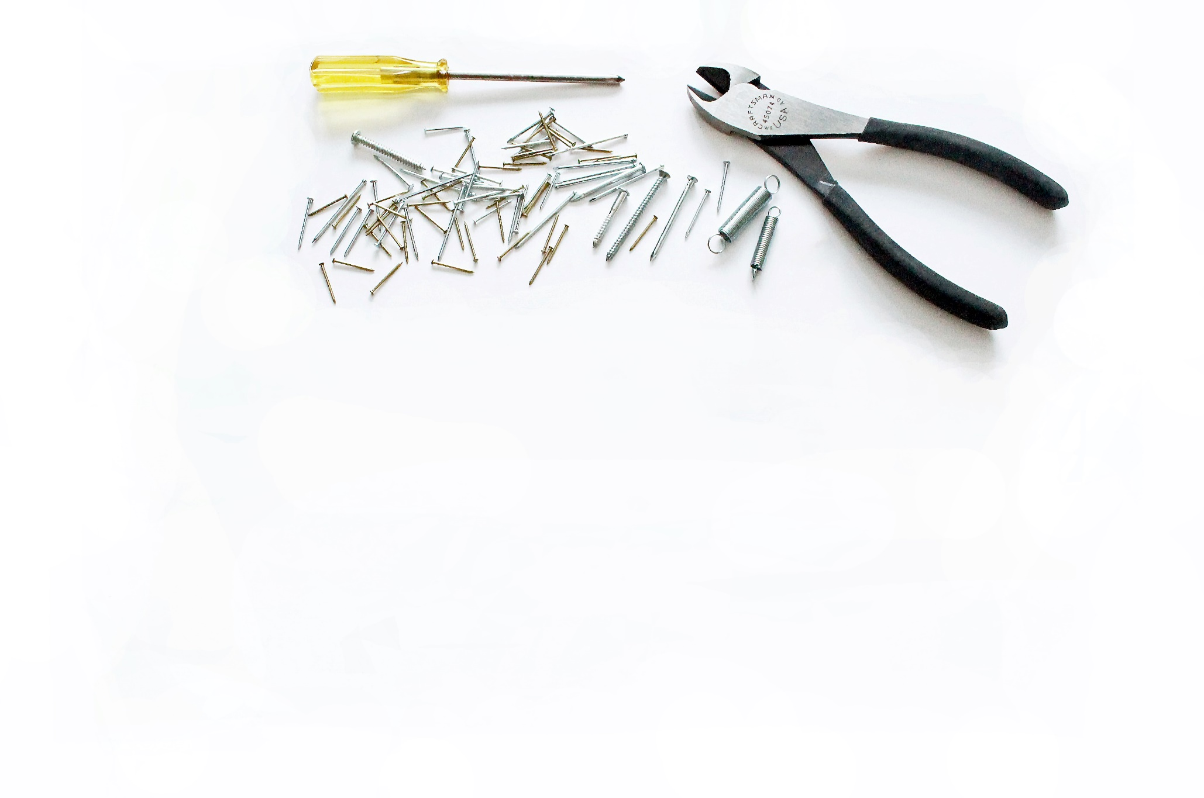
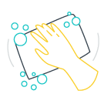
Remember to wipe down surfaces and door handles after they leave and wash your hands with soap and warm water afterwards.

These are unprecedented times for us all and we will endeavour to support our tenants to the best of our ability. If you have any questions please contact us on [insert agency phone number / email address].

Kind regards,
[INSERT YOUR SIGNATURE HERE]

